**COMSATS University Islamabad**

**Attock Campus**Department of Electrical and Computer Engineering

**Program:** BCE-4 Spring 2021

**Lab Sessional I  
Course:** Object Oriented Programming

**Time Allowed: 1h 15min Marks: 30**

**Name: Muhammad Kaleem Ullah Reg. No: FA19-BCE-007**

**Note:** Each question carries 15 marks

**Instructor’s E-mail id**: [laraib@cuiatk.edu.pk](mailto:laraib@cuiatk.edu.pk)

**Instructions:**

1. You have to submit your answer document & code file via both MS Teams & email.
2. Save document file with your Name and Registration number.
3. No late answers would be accepted.

**Question 1: [CLO-2,4]**

In ocean navigation, locations are measured in degrees and minutes of latitude and longitude. These locations are represented as 149 degrees 34.8 minutes west longitude, and 17 degrees 31.5 minutes south latitude. This is written as 149°34.8’ W, 17°31.5’ S. There are 60 minutes in a degree. Longitude is measured from 0 to 180 degrees, east or west from Greenwich. Latitude is measured from 0 to 90 degrees, north or south from the equator to the poles.

Create a **class angle** that includes three member variables: an int for degrees, a float for minutes, and a char for the direction letter (N, S, E, or W). This class can hold either a latitude variable or a longitude variable. Write one member function to obtain an angle value (in degrees & minutes) and a direction from the user, and a second to display the angle value in **“**179°59.9’E**”** format. Also write a three-argument constructor. Write a main() program that displays an angle initialized with the constructor, and then, within a loop, allows the user to input any angle value, and then displays the value.

Hint: You can use the hex character constant ‘\xF8’ , which usually prints a degree (°) symbol.

**Solution:**

* **Code:**

#include<iostream>

using namespace std;

class angle

{

//data member declaration

private:

int degrees;

float minutes;

char direction;

//data fucntions

public:

//Constructor

angle(int d=0,float m=0.0,char D='X')

{

degrees=d;

minutes=m;

direction=D;

}

//Functions to get value from users

void getValue()

{

cout<<"\nEnter the Degree : ";

cin>>degrees;

cout<<"\nEnter the Minutes : ";

cin>>minutes;

cout<<"\n Enter the Direction i.e \"N, S, E, or W\" : ";

cin>>direction;

}

//Functino to display Direction

void display()const

{

cout<<"\n Your Location : "<<degrees<<"\xF8"<<minutes<<"\'"<<direction;

}

};

int main()

{

int num; //a varible to get how many directions we want to enter

cout<<"How many locations you want to Enter to save it : ";

cin>>num;

angle a[num]; // class object creation in the array form

//for loop to get as much desire locations you have entered

for(int i=0;i<num;i++)

{

cout<<"Get "<<i+1<<" Number Location : ";

a[i].getValue();

}

system("CLS"); //a statment which will clear the screen after getting values from the user.

// for loop to display our locations

for(int i=0;i<num;i++)

{

cout<<"\nDisplay "<<i+1<<" Number Location : ";

a[i].display();

}

return 0;

}

* **Output:**

As I am using system(“CLS”) after getting input so I am attaching two photos of my output.

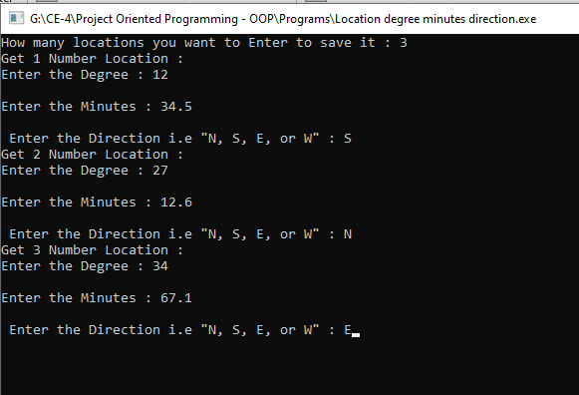

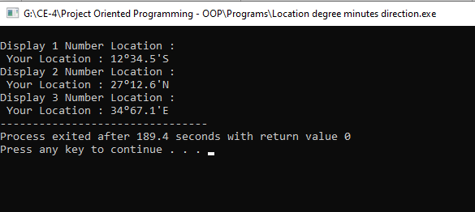

**Question 2: [CLO-3,4]**

Create the equivalent of a **four-function calculator**. The program should ask the user to enter a number, an operator, and another number. It should then carry out the specified arithmetical operation: adding, subtracting, multiplying, or dividing the two numbers using operator overloading. Use a switch statement to select the operation. Finally, display the result.

When it finishes the calculation, the program should ask whether the user wants to do another calculation. The response can be ‘y’ or ‘n’. Some sample interaction with the program might look like this:

Enter first number, operator, second number: 10 / 3

Answer = 3.333333

Do another (y/n)? y

Enter first number, operator, second number: 12 + 100

Answer = 112

Do another (y/n)? n

**Solution:**

* **Code:**

#include<iostream>

using namespace std;

class calculator

{

private:

int num1,num2;

float ans;

char opr;

public:

calculator(float a=0,int n1=0,int n2=0)

{

ans=a;

num1=n1;

num2=n2;

}

void getVal()

{

cout<<"Enter the First Number : "; cin>>num1;

cout<<"\nEnter the Operator : "; cin>>opr;

cout<<"\nEnter the Second Operator : "; cin>>num2;

}

char oper()

{

return opr;

}

int number1()

{

return num1;

}

int number2()

{

return num2;

}

float result()

{

return ans;

}

calculator operator +(calculator d2);

calculator operator -(calculator d2);

calculator operator *(calculator d2);

calculator operator /(calculator d2);

};

calculator calculator::operator +(calculator d2)

{

float A=d2.number1()+d2.number2();

cout<<d2.num1<<" + "<<d2.num2<<"="<<A;

return calculator(A);

}

calculator calculator::operator -(calculator d2)

{

float A=d2.number1()-d2.number2();

cout<<d2.num1<<" - "<<d2.num2<<"="<<A;

return calculator(A);

}

calculator calculator::operator *(calculator d2)

{

float A=d2.number1()*d2.number2();

cout<<d2.num1<<" * "<<d2.num2<<"="<<A;

return calculator(A);

}

calculator calculator::operator /(calculator d2)

{

float A=d2.number1()/d2.number2();

cout<<d2.num1<<" / "<<d2.num2<<"="<<A;

return calculator(A);

}

int main()

{

char choice;

calculator a1,a2;

do

{

a1.getVal();

switch(a1.oper())

{

case '+':

a2=a1+a1;

a2.result();

break;

case '-':

a2=a1-a1;

a2.result();

break;

case '*':

a2=a1*a1;

a2.result();

break;

case '/':

a2=a1/a1;

a2.result();

break;

default:

cout<<"INVALID OPERATOR"<<endl;

break;

} // end switch

cout<<"\nDO ANOTHER? (Y/N)? ";

cin>>choice;

}

while(choice != 'N');

return 0;

}

* **Output:**

